# **LAB REPORT-1**

# PRAKHAR SINGH PARMAR

# 1905261

* **LAB-1**

Q1. Write a program to create a list

<html>

    <body>

        <hr>

            <ul>

                <li>Vegetable</li>

                <ol>

                <li>brinjal</li>

                <li>cauliflower</li>

                <li>Cabbage</li>

                <li>Pumkin</li>

                </ol>

                <li>Fruits</li>

                <ol>

                    <li>Apple</li>

                    <li>Orange</li>

                    <li>Banana</li>

                    <li>Mango</li>

                </ol>

                <li>Dry fruits</li>

                <ol>

                    <li>Casewnuts</li>

                    <li>Rasins</li>

                    <li>Walnuts</li>

                </ol>

    </ul>

    </body>

</html>

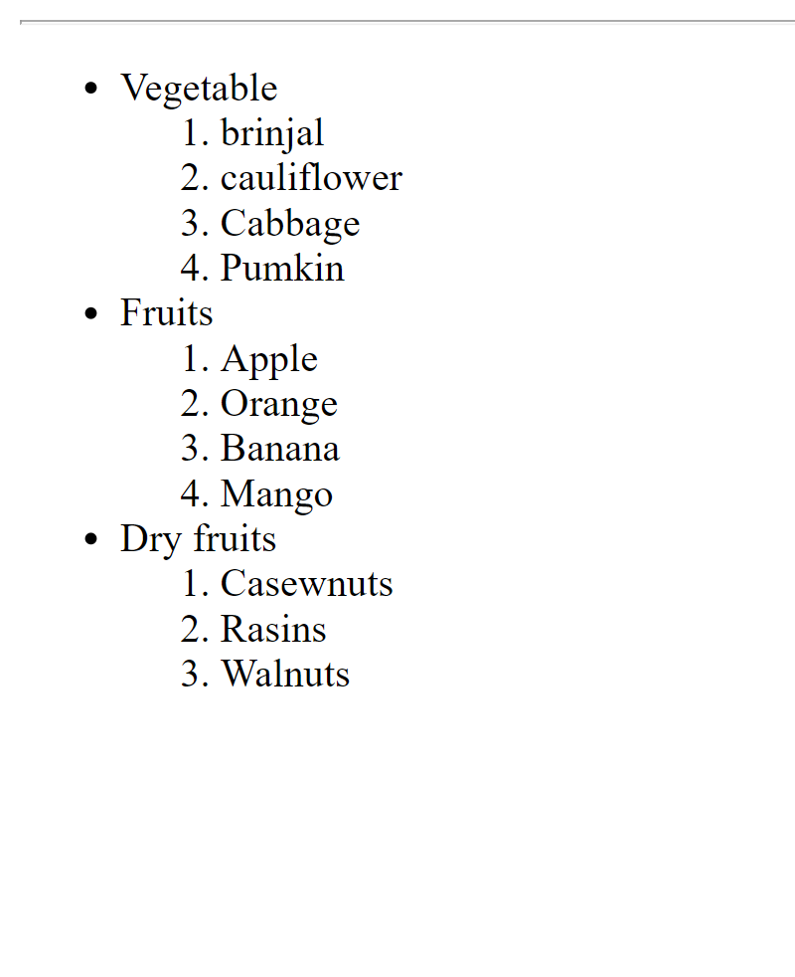

Q2. design this webpage

<!DOCTYPE html>

<html lang="en">

<head>

    <meta charset="UTF-8">

    <meta name="viewport" content="width=<device-width>, initial-scale=1.0">

    <title>Document</title>

    <style>

        h1 { text-align: center;}

        table, tr, th, td {border: black solid 2px;

        padding: 4px;}

        table { width: 50%;}

        #lab {text-align: right;}

    </style>

</head>

<body>

    <h1>GRADE SHEET</h1>

    <table>

        <tr>

            <th rowspan="2">S.No</th>

            <th rowspan="2">Subject name</th>

            <th colspan="2">Marks</th>

            <th>Total</th>

            <th>Grade</th>

        </tr>

        <tr>

            <th>Internal</th>

            <th>External</th>

            <th>97</th>

            <th>O</th>

        </tr>

        <tr>

            <td>1</td>

            <td>English</td>

            <td>47</td>

            <td>41</td>

            <td>88</td>

            <td>E</td>

        </tr>

        <tr>

            <td>2</td>

            <td>Hindi</td>

            <td>46</td>

            <td>44</td>

            <td>90</td>

            <td>O</td>

        </tr>

        <tr>

            <td>3</td>

            <td>Science</td>

            <td>48</td>

            <td>49</td>

            <td>88</td>

            <td>O</td>

        </tr>

        <tr>

            <td>4</td>

            <td>Maths</td>

            <td>45</td>

            <td>42</td>

            <td>87</td>

            <td>E</td>

        </tr>

        <tr>

            <th id="lab" colspan="5">SGPA</th>

            <td></td>

        </tr>

</table>

</body>

</html>

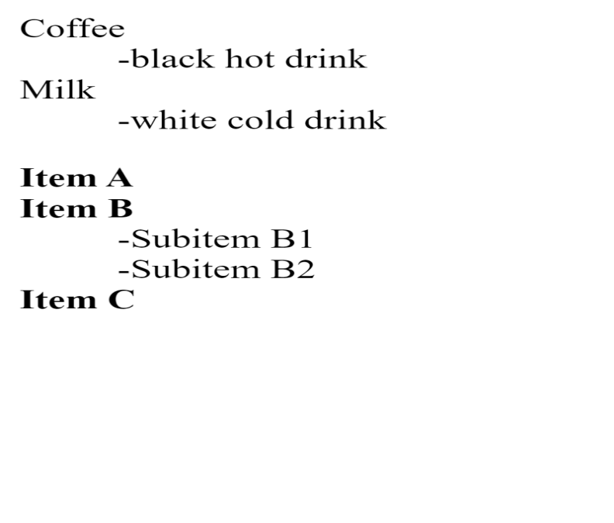

Q3. design this table

<!DOCTYPE html>

<html lang="en">

<head>

    <meta charset="UTF-8">

    <meta name="viewport" content="width=device-width, initial-scale=1.0">

    <title>Document</title>

    <style>

        h1 { text-align: center;}

        table, tr, th, td {border: solid black 2px;

        padding: 4px;

        border-collapse: collaps;}

        #lab {text-align: right;}

    </style>

</head>

<body>

    <table style="width: 60%;">

        <tr>

            <th>QUALIFICATION</th>

            <th>

                <table>

                    <tr>

                        <th>S.No</th>

                        <th>Name of Examination</th>

                        <th>Name of School/College</th>

                        <th>Percentage/Grade</th>

                    </tr>

                    <tr>

                        <td>1</td>

                        <td>10th</td>

                        <td>St.Fidelis College</td>

                        <td>90%</td>

                    </tr>

                    <tr>

                        <td>2</td>

                        <td>10+2</td>

                        <td>St.Fidelis College</td>

                        <td>80%</td>

                    </tr>

                </table>

            </th>

        </tr>

        <tr>

            <th>GRADE SHEET</th>

            <th>

                <h1>GRADE SHEET</h1>

    <table style="padding: 10px;">

        <tr>

            <th rowspan="2">S.No</th>

            <th rowspan="2">Subject name</th>

            <th colspan="2">Marks</th>

            <th>Total</th>

            <th>Grade</th>

        </tr>

        <tr>

            <th>Internal</th>

            <th>External</th>

            <th>97</th>

            <th>O</th>

        </tr>

        <tr>

            <td>1</td>

            <td>English</td>

            <td>47</td>

            <td>41</td>

            <td>88</td>

            <td>E</td>

        </tr>

        <tr>

            <td>2</td>

            <td>Hindi</td>

            <td>46</td>

            <td>44</td>

            <td>90</td>

            <td>O</td>

        </tr>

        <tr>

            <td>3</td>

            <td>Science</td>

            <td>48</td>

            <td>49</td>

            <td>88</td>

            <td>O</td>

        </tr>

        <tr>

            <td>4</td>

            <td>Maths</td>

            <td>45</td>

            <td>42</td>

            <td>87</td>

            <td>E</td>

        </tr>

        <tr>

            <th id="lab" colspan="5">SGPA</th>

            <td>9.7</td>

        </tr>

    </table>

            </th>

        </tr>

    </table>

</body>

</html>

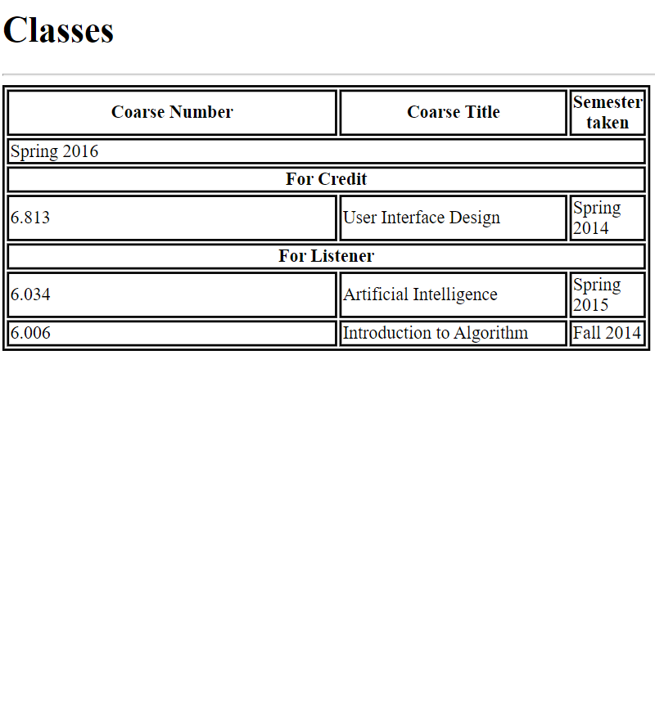

Q4. Make a biodata

<html>

    <head>

        <title>BIO-DATA</title>

    </head>

    <body>

        <h1 align="center" font color="brinjal"><u>BIO-DATA</u></h1>

        <img src="me.jpeg" width="33%" height="40%">

        <table>

            <tr>

                <td>Personal</td>

                <td>:</td>

            </tr>

            <tr>

                <td><u>Name</u></td>

                <td>:</td>

                <td>PRAKHAR SINGH PARMAR</td>

            </tr>

            <tr>

                <td><u>Date Of Birth</u></td>

                <td>:</td>

                <td>18<sup>th</sup> March, 2000 (2:03 P.M.)</td>

            </tr>

            <tr>

                <td><u>Place of Birth</u></td>

                <td>:</td>

                <td>Kanpur</td>

            </tr>

            <tr>

                <td><u>Education</u></td>

                <td>:</td>

                <td>B.Tech</td>

            </tr>

            <tr>

                <td><u>Height</u></td>

                <td>:</td>

                <td>5<sup>'</sup>9<sup>"</sup></td>

            </tr>

            <tr>

                <td><u>Hobbies</u></td>

                <td>:</td>

                <td>Music, Gaming, Sports</td>

            </tr>

            <tr><hr>

            </tr>

            <tr>

                <td><font color="Red"><u>Family Background<u></u></font></td>

            </tr>

            <tr>

                <td><u>Father's Name</u></td>

                <td>:</td>

                <td>Sandeep Parmar</td>

            </tr>

            <tr>

                <td><u>Mother's Name</u></td>

                <td>:</td>

                <td>Archana Singh Parmar</td>

            </tr>

            <tr>

                <td><u>Siblings</u></td>

                <td>:</td>

                <td>None</td>

            </tr>

            <tr>

                <td><u>Native Place</u></td>

                <td>:</td>

                <td>Lucknow</td>

            </tr>

        </table>

    </body>

</html>

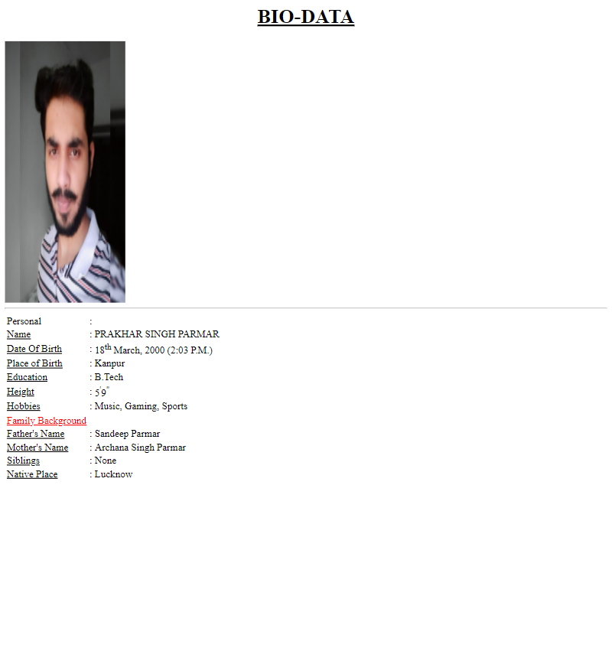

* **LAB 2**

**PRAKHAR SINGH PARMAR**

**1905261**

Q5. Design a grade sheet

<html>

    <body>

        <hr>

            <ul>

                <li>Vegetable</li>

                <ol>

                <li>brinjal</li>

                <li>cauliflower</li>

                <li>Cabbage</li>

                <li>Pumkin</li>

                </ol>

                <li>Fruits</li>

                <ol>

                    <li>Apple</li>

                    <li>Orange</li>

                    <li>Banana</li>

                    <li>Mango</li>

                </ol>

                <li>Dry fruits</li>

                <ol>

                    <li>Casewnuts</li>

                    <li>Rasins</li>

                    <li>Walnuts</li>

                </ol>

    </ul>

    </body>

</html>

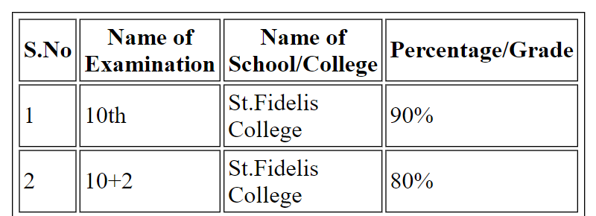

Q6. Design a table

<!DOCTYPE html>

<html lang="en">

<head>

    <meta charset="UTF-8">

    <meta name="viewport" content="width=<device-width>, initial-scale=1.0">

    <title>Document</title>

    <style>

        h1 { text-align: center;}

        table, tr, th, td {border: black solid 2px;

        padding: 4px;}

        table { width: 50%;}

        #lab {text-align: right;}

    </style>

</head>

<body>

    <h1>GRADE SHEET</h1>

    <table>

        <tr>

            <th rowspan="2">S.No</th>

            <th rowspan="2">Subject name</th>

            <th colspan="2">Marks</th>

            <th>Total</th>

            <th>Grade</th>

        </tr>

        <tr>

            <th>Internal</th>

            <th>External</th>

            <th>97</th>

            <th>O</th>

        </tr>

        <tr>

            <td>1</td>

            <td>English</td>

            <td>47</td>

            <td>41</td>

            <td>88</td>

            <td>E</td>

        </tr>

        <tr>

            <td>2</td>

            <td>Hindi</td>

            <td>46</td>

            <td>44</td>

            <td>90</td>

            <td>O</td>

        </tr>

        <tr>

            <td>3</td>

            <td>Science</td>

            <td>48</td>

            <td>49</td>

            <td>88</td>

            <td>O</td>

        </tr>

        <tr>

            <td>4</td>

            <td>Maths</td>

            <td>45</td>

            <td>42</td>

            <td>87</td>

            <td>E</td>

        </tr>

        <tr>

            <th id="lab" colspan="5">SGPA</th>

            <td></td>

        </tr>

    </table>

</body>

</html>

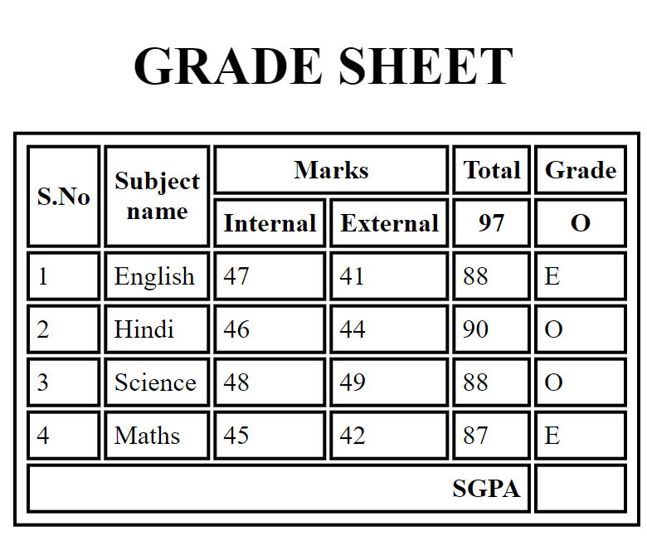

Q7. Design a combined table

<!DOCTYPE html>

<html lang="en">

<head>

    <meta charset="UTF-8">

    <meta name="viewport" content="width=device-width, initial-scale=1.0">

    <title>Document</title>

    <style>

        h1 { text-align: center;}

        table, tr, th, td {border: solid black 2px;

        padding: 4px;

        border-collapse: collaps;}

        #lab {text-align: right;}

    </style>

</head>

<body>

    <table style="width: 60%;">

        <tr>

            <th>QUALIFICATION</th>

            <th>

                <table>

                    <tr>

                        <th>S.No</th>

                        <th>Name of Examination</th>

                        <th>Name of School/College</th>

                        <th>Percentage/Grade</th>

                    </tr>

                    <tr>

                        <td>1</td>

                        <td>10th</td>

                        <td>St.Fidelis College</td>

                        <td>90%</td>

                    </tr>

                    <tr>

                        <td>2</td>

                        <td>10+2</td>

                        <td>St.Fidelis College</td>

                        <td>80%</td>

                    </tr>

                </table>

            </th>

        </tr>

        <tr>

            <th>GRADE SHEET</th>

            <th>

                <h1>GRADE SHEET</h1>

    <table style="padding: 10px;">

        <tr>

            <th rowspan="2">S.No</th>

            <th rowspan="2">Subject name</th>

            <th colspan="2">Marks</th>

            <th>Total</th>

            <th>Grade</th>

        </tr>

        <tr>

            <th>Internal</th>

            <th>External</th>

            <th>97</th>

            <th>O</th>

        </tr>

        <tr>

            <td>1</td>

            <td>English</td>

            <td>47</td>

            <td>41</td>

            <td>88</td>

            <td>E</td>

        </tr>

        <tr>

            <td>2</td>

            <td>Hindi</td>

            <td>46</td>

            <td>44</td>

            <td>90</td>

            <td>O</td>

        </tr>

        <tr>

            <td>3</td>

            <td>Science</td>

            <td>48</td>

            <td>49</td>

            <td>88</td>

            <td>O</td>

        </tr>

        <tr>

            <td>4</td>

            <td>Maths</td>

            <td>45</td>

            <td>42</td>

            <td>87</td>

            <td>E</td>

        </tr>

        <tr>

            <th id="lab" colspan="5">SGPA</th>

            <td>9.7</td>

        </tr>

    </table>

            </th>

        </tr>

    </table>

</body>

</html>

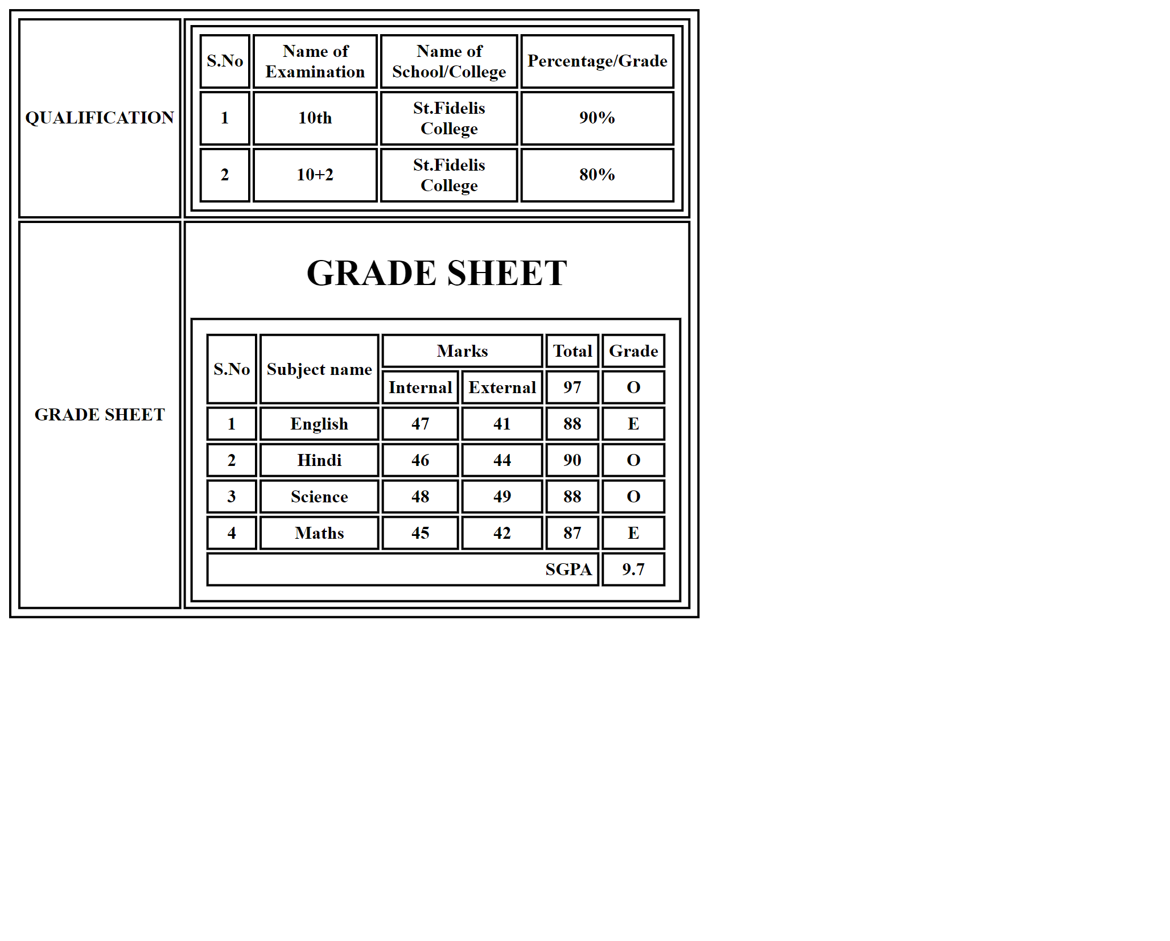

Q4. Design a biodata form

<!DOCTYPE html>

<html lang="en">

<head>

    <meta charset="UTF-8">

    <meta name="viewport" content="width=device-width, initial-scale=1.0">

    <title>Document</title>

</head>

<body>

    <body>

        <h1 align="center" font color="brinjal"><u>BIO-DATA</u></h1>

        <form>

        <table>

            <tr>

                <td><font color="Red"><u>Personal<u></u></font></td>

                <td>:</td>

            </tr>

            <tr>

                <td><u>Name</u></td>

                <td>:</td>

                <td><input type="text" name="name" required></td>

            </tr>

            <tr>

                <td>Gender</td>

                <td>:</td>

                <td><input type="radio" name="Gender" id="Male">Male

                    <input type="radio" name="Gender" id="Female">Female</td>

                </td>

            </tr>

            <tr>

                <td><u>Date Of Birth</u></td>

                <td>:</td>

                <td><input type="date" name="date" id="date"></td>

            </tr>

            <tr>

                <td><u>Place of Birth</u></td>

                <td>:</td>

                <td><input type="text" name="name" required></td>

            </tr>

            <tr>

                <td><u>Education</u></td>

                <td>:</td>

                <td><select name="educayion" id="edu">

                    <option value="">--Coarse--</option>

                    <option value="btech">B.Tech</option>

                    <option value="mtech">M.Tech</option>

                    <option value="mba">MBA</option>

                </select></td>

            </tr>

            <tr>

                <td><u>Height</u></td>

                <td>:</td>

                <td><input type="number" name="feet"><sup>'</sup><input type="inch" name="name"><sup>"</sup></td>

            </tr>

            <tr>

                <td><u>Hobbies</u></td>

                <td>:</td>

                <td>Music, Gaming, Sports</td>

            </tr>

            <tr><hr>

            </tr>

            <tr>

                <td><font color="Red"><u>Family Background<u></u></font></td>

            </tr>

            <tr>

                <td><u>Father's Name</u></td>

                <td>:</td>

                <td><input type="text" name="name" required></td></td>

            </tr>

            <tr>

                <td><u>Mother's Name</u></td>

                <td>:</td>

                <td><input type="text" name="name" required></td></td>

            </tr>

            <tr>

                <td><u>Siblings</u></td>

                <td>:</td>

                <td><select name="card_type" id="card_type">

                    <option value="">--Siblings--</option>

                    <option value="none">None</option>

                    <option value="one">1</option>

                    <option value="two">2</option>

                </select></td>

            </tr>

            <tr>

                <td><u>Native Place</u></td>

                <td>:</td>

                <td><input type="text" name="name" required></td></td>

            </tr>

            <tr>

                <td>

                <input type="button" name="Submit" value="Submit">

                </td>

            </tr>

        </table>

        </form>

    </body>

</body>

</html>

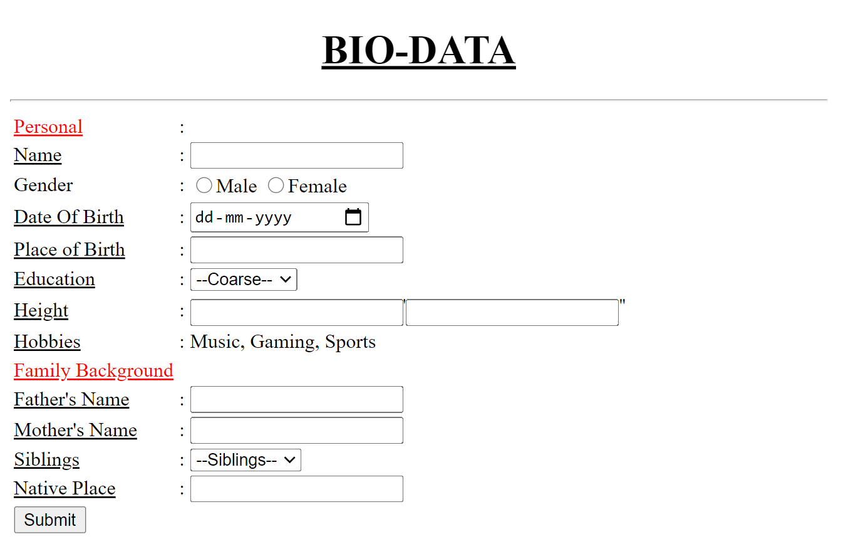

* **LAB 3**
* Frame 1

<!DOCTYPE html>

<html lang="en">

<head>

    <title>Frame 1</title>

</head>

<body bgcolor="green">

    <h1>"FRAME 1"</h1>

    <h2>"this is content of frame 1"</h2>

</body>

</html>

* Frame 2

<!DOCTYPE html>

<html lang="en">

<head>

    <title>Frame 2</title>

</head>

<body bgcolor="yellow">

    <h1>"FRAME 2"</h1>

    <h2>"this is content of frame 2"</h2>

</body>

</html>

* Frame 3

<!DOCTYPE html>

<html lang="en">

<head>

    <title>Frame 3</title>

</head>

<body bgcolor="burlywood">

    <h1>"FRAME 3"</h1>

    <h2>"this is content of frame 3"</h2>

</body>

</html>

* Frame 4

<!DOCTYPE html>

<html lang="en">

<head>

    <title>Frame 4</title>

</head>

<body bgcolor="red">

    <h1>"FRAME 4"</h1>

    <h2>"this is content of frame 4"</h2>

</body>

</html>

Q1.

<!DOCTYPE html>

<html lang="en">

<head>

    <title>frame 1</title>

</head>

<frameset rows="50%,50%">

    <frameset cols="50%,50%">

        <frame src="frame doc 1.html" frameborder="1">

        <frame src="frame doc 2.html" frameborder="1">

    </frameset>

    <frameset cols="50%,50%">

        <frame src="frame doc 3.html" frameborder="1">

        <frame src="frame doc 4.html" frameborder="1">

    </frameset>

</frameset>

</html>

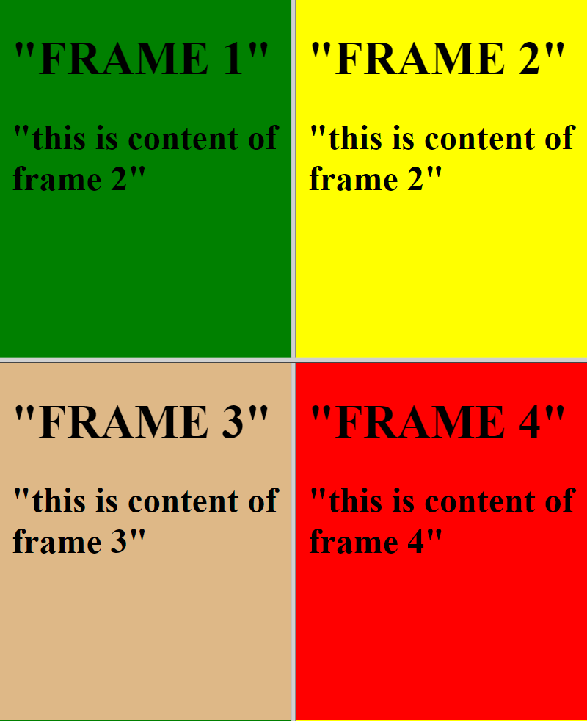

Q2.

<!DOCTYPE html>

<html lang="en">

<head>

    <title>frame 2</title>

</head>

<frameset rows="*,*">

    <frameset cols="100%">

        <frame src="frame doc 1.html" frameborder="1">

    </frameset>

    <frameset cols="33%,33%,*">

        <frame src="frame doc 2.html" frameborder="1">

        <frame src="frame doc 3.html" frameborder="1">

        <frame src="frame doc 4.html" frameborder="1">

    </frameset>

</frameset>

</html>

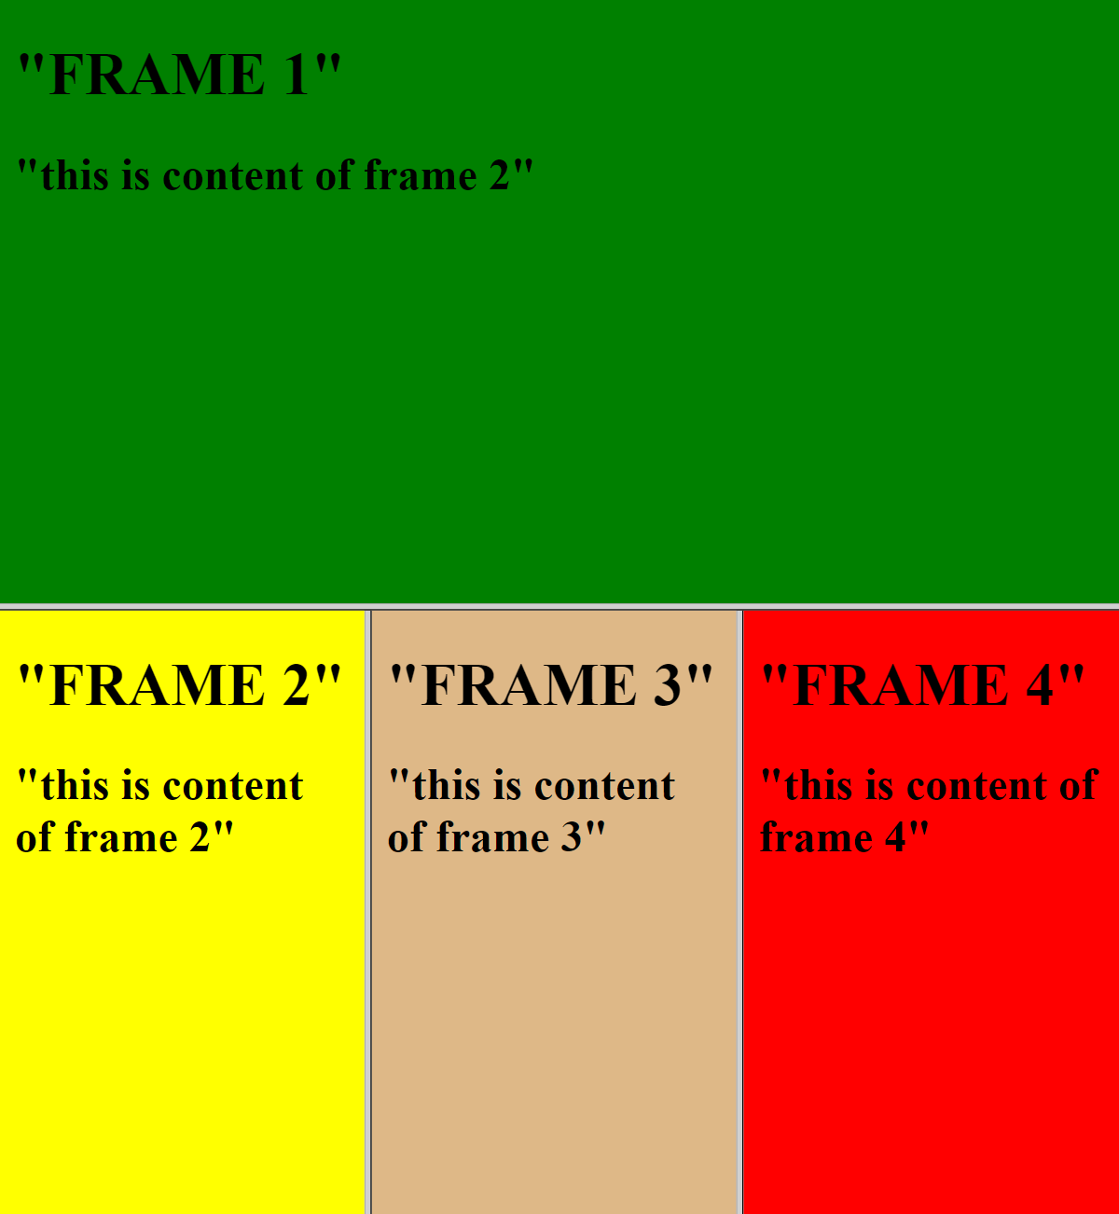

Q3.

<!DOCTYPE html>

<html lang="en">

<head>

    <title>frame 3</title>

</head>

<frameset cols="50%,*">

        <frame src="frame doc 1.html" frameborder="1">

        <frameset rows="50%,*">

            <frame src="frame doc 2.html" frameborder="1"></frame>

            <frameset cols="50%,*">

                <frame src="frame doc 3.html" frameborder="1">

                <frame src="frame doc 4.html" frameborder="1">

            </frameset>

        </frameset>

</frameset>

</html>

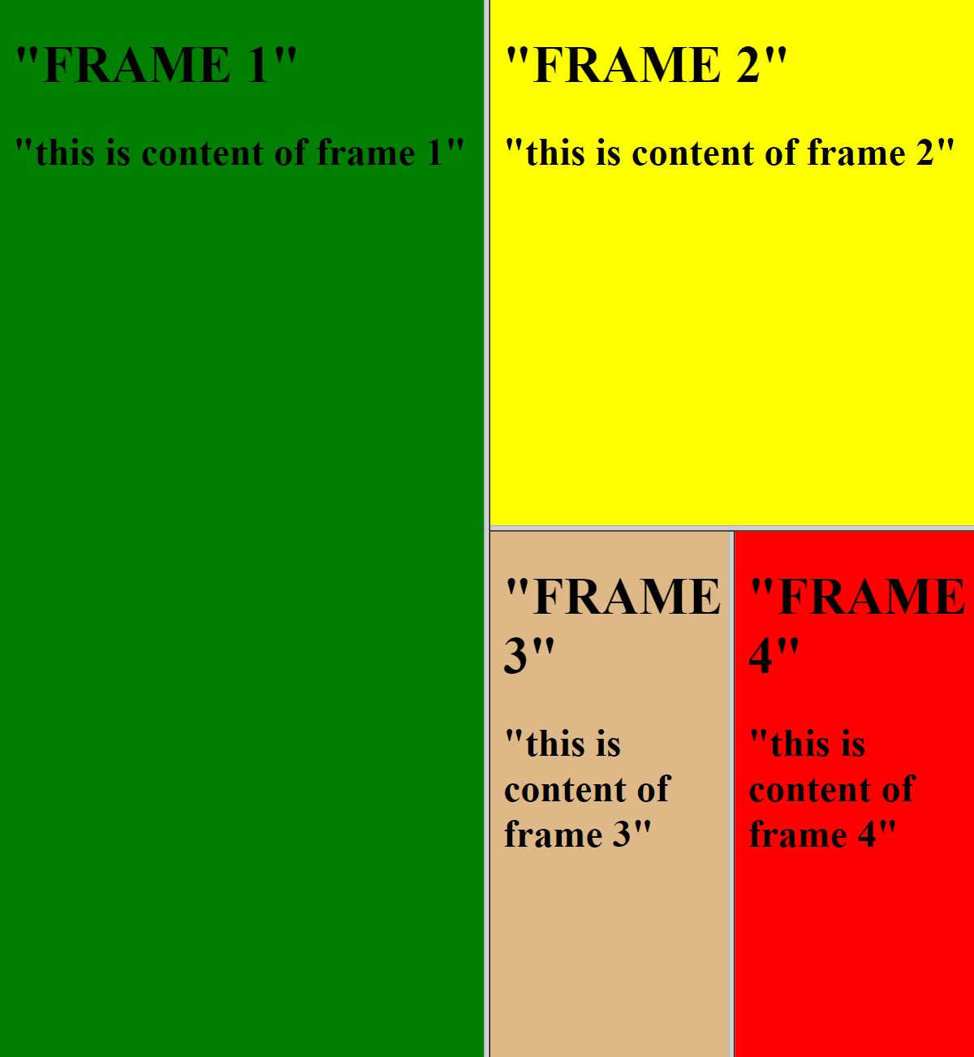

Q4.

<!DOCTYPE html>

<html lang="en">

<head>

    <title>frame 4</title>

</head>

<frameset rows="20%,*">

        <frame src="my webpage.html" frameborder="1">

        <frameset cols="30%,*">

            <frameset rows="*,*">

                <frame src="biodata _side.html" target= frameborder="1"></frame>

                <frame src="kiit_google_fb.html" frameborder="1"></frame>

            </frameset>

                <frame src="f4.html" frameborder="1" name="MainPage">

        </frameset>

</frameset>

</html>

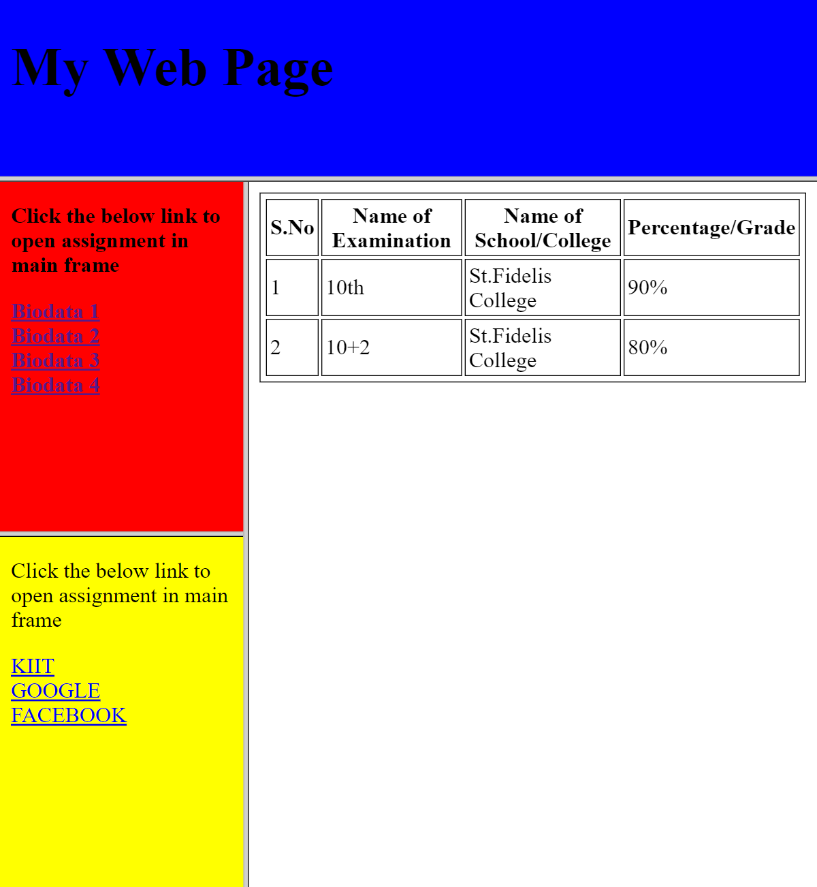

**PRAKHAR SINGH PARMAR 1905261.**